**Design and Analysis of Algorithm**

**Experiment No. : 6**

**Write a program to implement prim’s and Kruskal’s algorithm.**

Experiment No. 6

1. **Aim:** Write a program to implement prim’s and Kruskal’s algorithm.
2. **Algorithm**

A Minimum Spanning Tree (MST)

* is a subgraph of an undirected graph such that the subgraph spans (includes) all nodes
* Weighted graph.
* All nodes should be connected
* Graph does not have cycles.
* Sum of all weights should be minimum.

};

**Kruskal’s Algorithm**

**Step-01:**

Sort all the edges from low weight to high weight.

**Step-02:**

Take the edge with the lowest weight and use it to connect the vertices of graph.

If adding an edge creates a cycle, then reject that edge and go for the next least weight edge.

**Step-03:**

Keep adding edges until all the vertices are connected and a Minimum Spanning Tree (MST) is obtained.

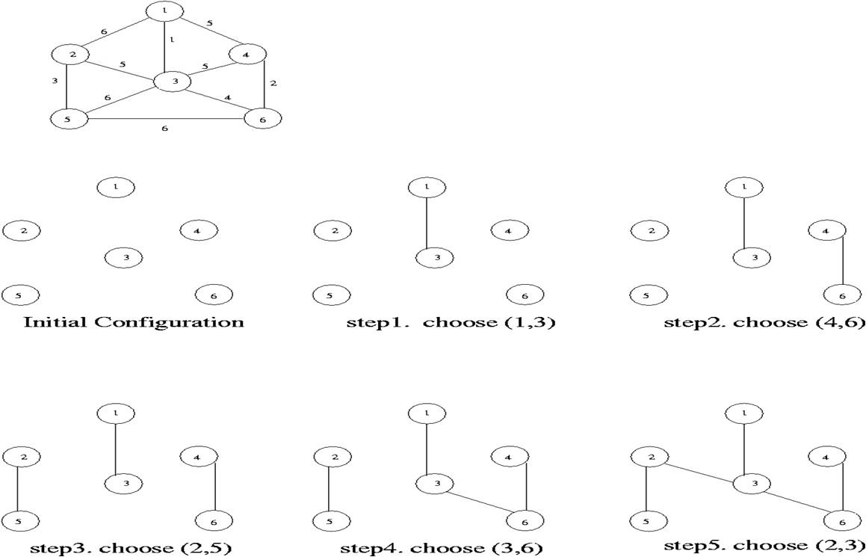

**Prims Algorithm**

The steps for implementing Prim's algorithm are as follows:

1. Initialize the minimum spanning tree with a vertex chosen at random.
2. Find all the edges that connect the tree to new vertices, find the minimum and add it to the tree
3. Keep repeating step 2 until we get a minimum spanning tree.

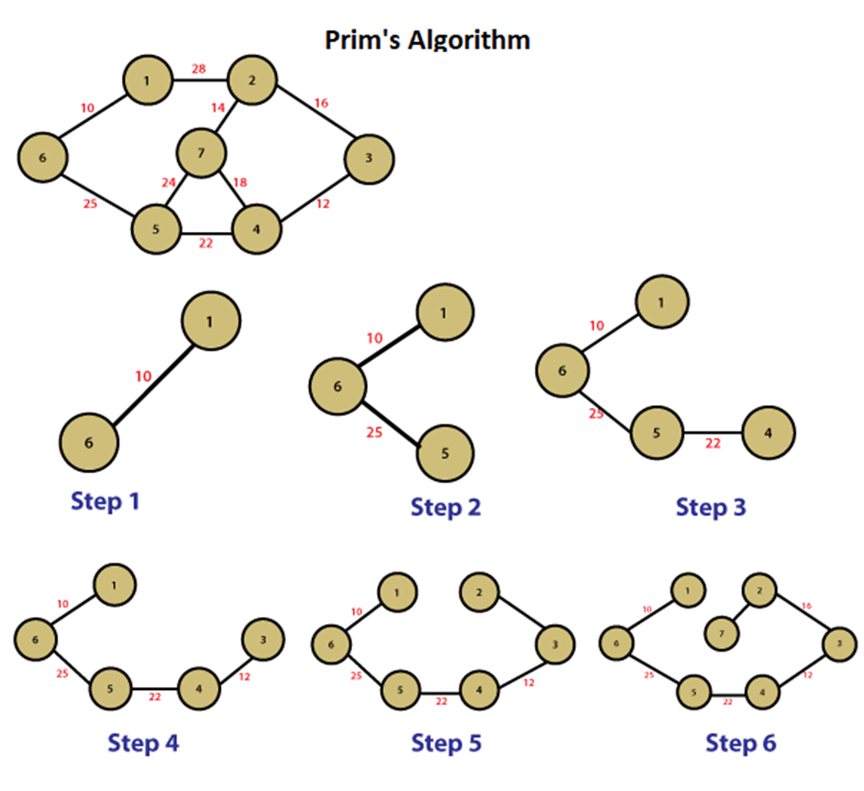

1. **Conclusion and Discussion:** Hence we have implemented Prims and Kruskal’s algorithm by using greedy approach.